**Calculate Function from Context Perspective**

We have the default Sales table, in which many records of TShirts of color blue, red, green, etc.

Initially, as usual, import the Sales_Data file’s Sales sheet in PBI.

Now, we want to make a table which will show **color wise total of quantity**.

We will create **a new table**.

**Colors = Distinct(Sales[Color])**

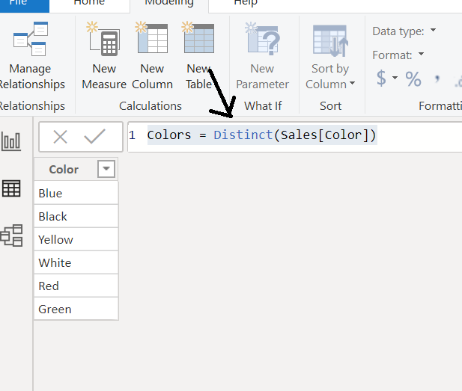

**** We need to establish relationship (means join) of this new table Colors and existing table Sales with of course the Color column!****

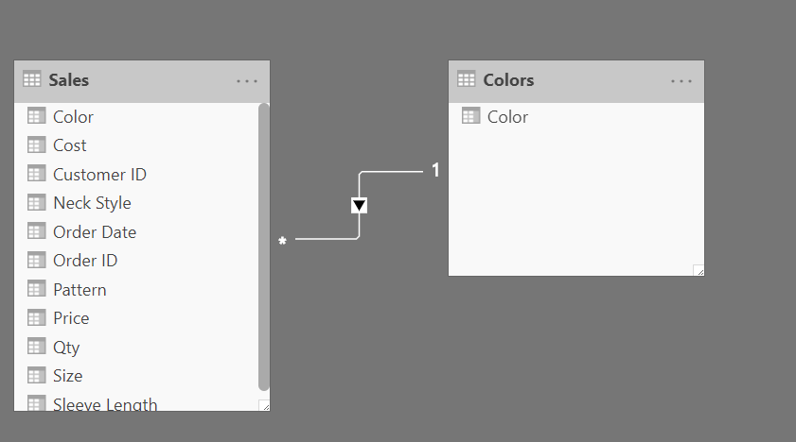

After the relation is created, we can now create a **new column** **Color-wise Sum of Qty** using the Calculate function.

**Color-wise Sum of Qty = Calculate(Sum(Sales[Qty]))**

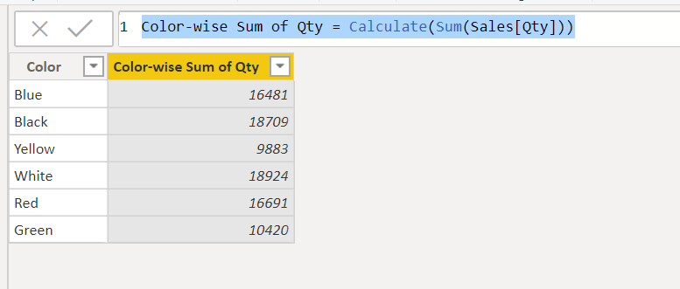

**How did it work but????**

The Calculate function takes care of **the user relationship context** of tables. Because the relationship was already created it simply took each color as the filter value and did summation of qty color wise!!!

CALCULATE performs the context transition. It uses the current value of columns in the original row contexts to provide a filter with a unique value for all the columns currently being iterated in the original row contexts.  Once all **implicit filters** created by the context transition are applied to the new filter context, CALCULATE moves on to the next step.